Da’wah to Hindus

Da’wah to Hindus
Hindu: The word ‘Hindu’ comes from the word ‘Sindhu,’ a region watered by The River Indus. Therefore being a Hindu is about place of birth i.e. geography not beliefs.
Founder of Hinduism: None

Major Beliefs:
- Belief in Vedas –Hindu Scriptures
- Practice of Caste system – People are born into a group which determines their social status and profession (jobs)
- Sanctity of Cow and other animals.
- Belief in One or many gods.
- Reincarnation.
- Incarnation of Gods into animals or humans.

Religious Books of Hinduism
Two Main Books:- Shruti and Shmrti.
1) Shruti = revealed
> Vedas and the Upanishads
2) Shmrti = memorized
Puranas and Itihas
(includes Bhagwad Gita )

Concept of God in Hinduism
Common Hindu says > 300 millions
Their Scholars say > Only One !

What their Scripture says:
“He is the one and only…” Chandogya Upanishad [Chapter 6, Khanda 2, Shloka 1]
“Bhagwan ek hi hai …” (There is only One God…”) Brahma Sutra of Hindu Vedanta.

Is Idol Worship Allowed ?
The Key Question

“Excuse me Brother,[Bhai-Saab,Sir,] did you know that in the The Brahma Sutra,
It says Bhagwan ek hi hai ,God is only One.

From the Yajur Vedha
- “ There Is No Image Of Him”
- "...of That God You Cannot Make Any Images.“
- “They enter darkness, those who worship
natural things” Eg. air, water, fire etc 40:9
- “They sink deeper in darkness those who worship
sambhuti” created things like idols.

>>Therefore The Scriptures Have a Correct
Concept of God
Idols are NOT allowed.

The Name Allah Is Preferred To “God”
It’s a unique Word & therefore creates No mental Picture.
Allah is mentioned in The Hindu Scriptures:
- Rigveda Book 2 hymn 1 verse 11
- Book 3 hymn 30 verse 10
‘ALO Upanishad’- Which should be pronounced ‘Allah Upanishad’
‘Allah’ is mentioned several times

Muhammad (PBUH) Prophesied In The Hindu Scriptures

Muhammad (PBUH) is Prophesied by name In ‘Bhavishya Purana’
“A Malechha (foreigner ) spiritual teacher will appear with his companions (Sahaba),His name will be Mohammad…” “ He has collected a great force to kill the Devil [abolish idol worship ].”

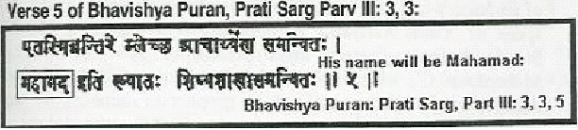

Muhammad (PBUH) Prophesied By The Name “Ahmed”

- Samveda Book II, Hymn 6, Verse 8:-

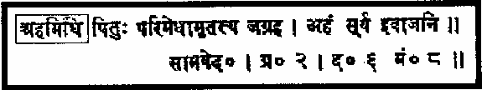

“Ahmed acquired religious law from his Lord which is full of wisdom.”

Also in many other places mentioned below

Samveda
Uttararchika, mantra 1500
Part 2 Book 7 chapter 1 section 5 verse 1
Indra chapter 2 mantra 152
Book 2 chapter 2 decade 1 verse 8
Yajurveda Chapter 31 verse 18
Rig-Veda Book 8 hymn 6 verse 10
Atharvaveda
Book 8 chapter 5 verse 16
Book 20 chapter 126 verse 14

.
Concentrate on showing that their scripture talks about worshipping One God and is against worshipping idols.

Bhagavat Gita 7:19-21: ‘All those who do idol worship, all those who worship demigods are materialistic people.’
Yajur Veda 3:32: ‘…Of that God you cannot make any images.
Yajur Veda 40:8: ‘All those who worship the uncreated things, they are in darkness, and you’ll enter more into darkness if you worship the created things.’
Rig Veda Vol.6, 45:16: ‘There is only one God, worship Him.’

Also show that the arrival of The Prophet Muhammad (PBUH) is described on many occasions in their ‘holy’ books

Therefore For Da’wah to a Hindu :

- Hindu Scripture Says One God

- Hindu Scripture Says: No Idol Worship

- Hindu Scripture Mentions Prophet Muhammad (PBUH)

- The Quran is a miracle

- Therefore Islam is true

- Therefore Muhammad (s) is A Messenger of Allah

Proof of Islam = The Qur’an
The Qur’an = A Miracle

